Preparation
- As soon as possible after the night is over, stop the automatic pumping of nitrogen using the ippower interface; hit login and set 'N2COR AutoFill' in status OFF. Note the 'N2COR ForceFill' should be OFF as well.
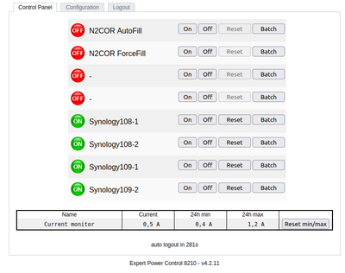
- Before the start of the pumping, change the heating setpoint on glslogin1
set_lakeshore -C 30
(the version is the beta one and you will have a warning; simply type enter)

Cryostat Coralie: Pumping Procedure
Coralie Pumping Schema 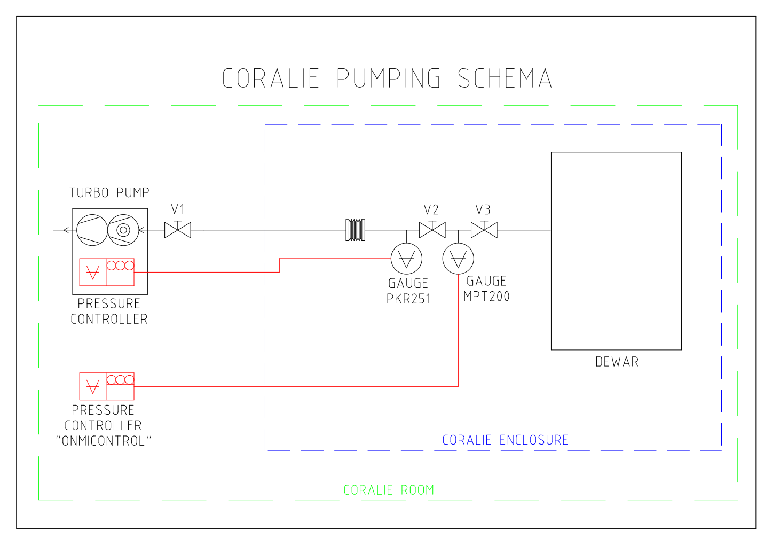
In the computer room, go inside the Coralie Room
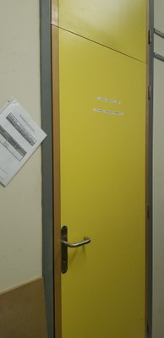
Use the ladder inside the Coralie room to reach the roof of the Coralie enclosure, where the pump unit and the controller “Omnicontrol” is located.
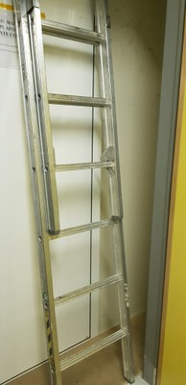--- 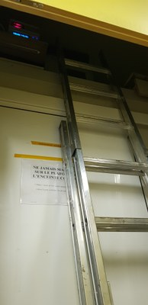
Switch on the lamp
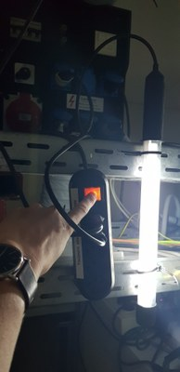
Check the pressure of the MPT200 gauge displayed on the “OMNICONTROL” pressure controller. If the pressure is > 1 mbar, an emergency pumping is mandatory (see procedure in the next chapter)
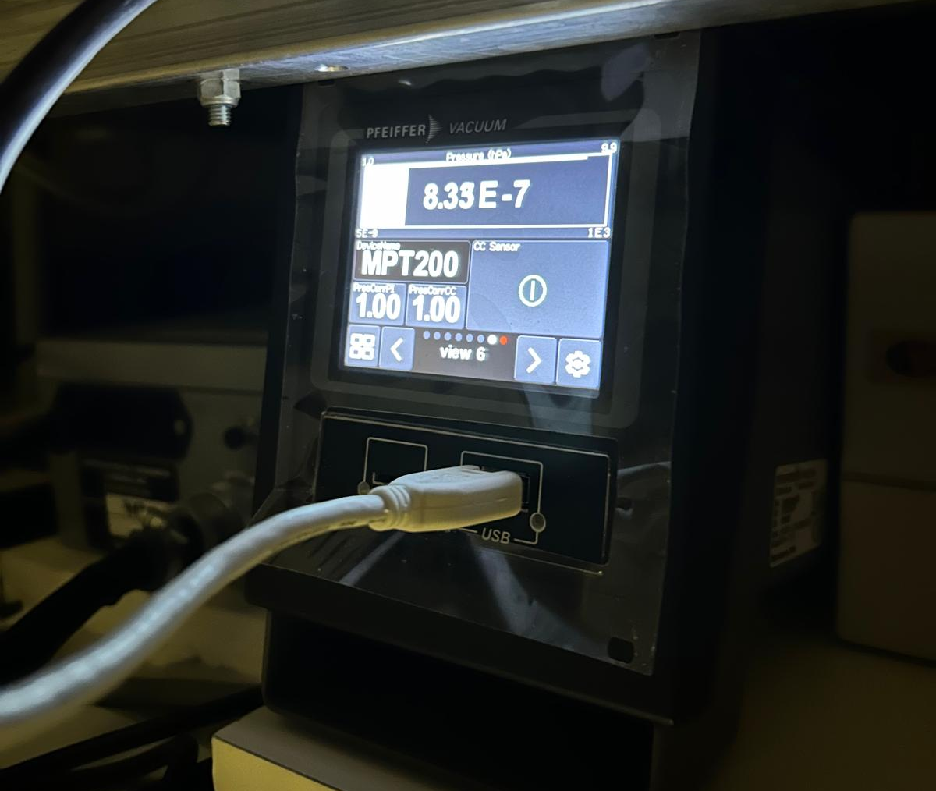
At this point, the status of the pumping should be:
- Valve V1 -> closed
- Valve V2 -> closed
- Valve V3 -> open
Check the 3 valves to confirm the situation.
V1 is on the roof, attached to the Turbo-Pump.
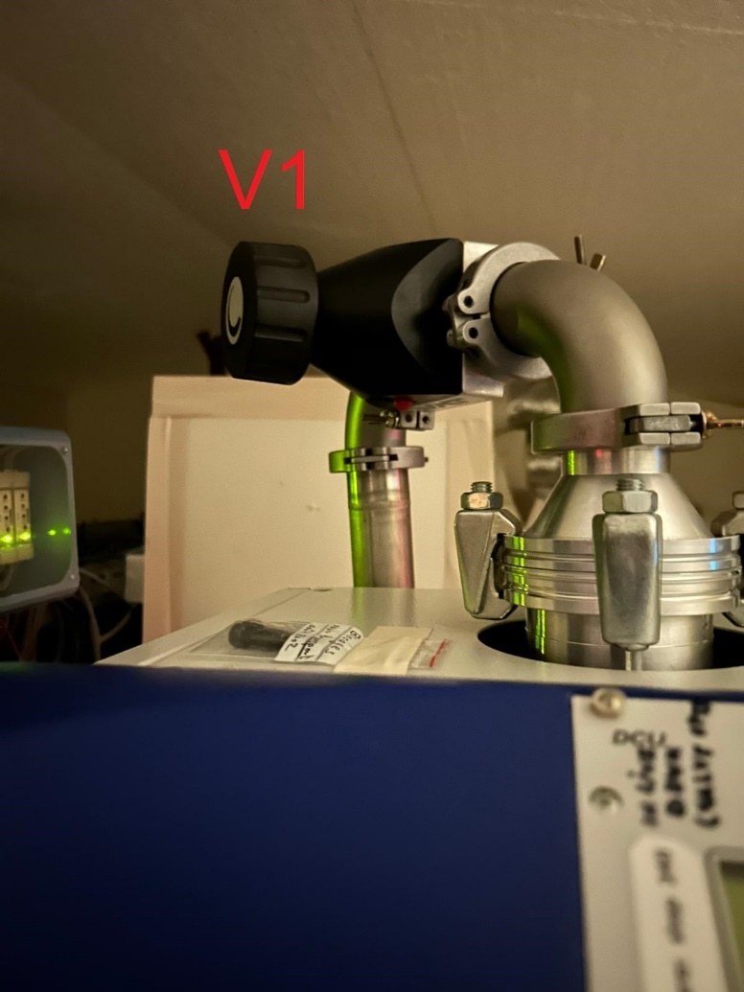
V2 and V3 are inside Coralie Enclosure.
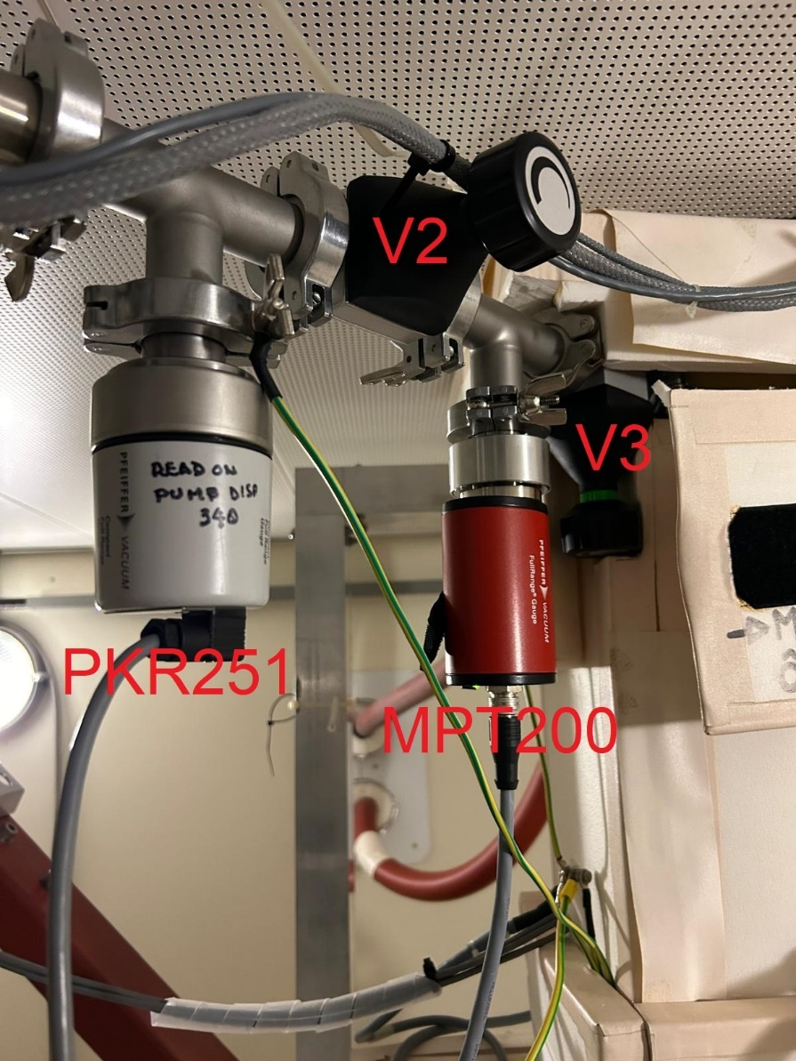
Enter Coralie Enclosure by sliding the door to the right (locker code: 129)
Switch on the Pump unit using the power switch located on the back of the unit, on the upper right side (as looking from the front):
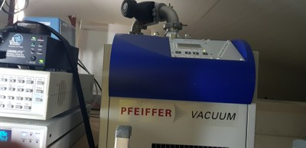
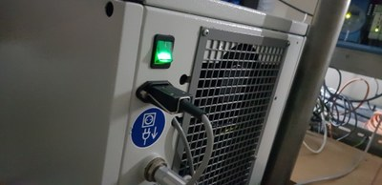
After starting the pump unit controller, wait until the controller is ready and press button On/Off button to start pumping
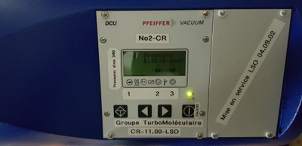
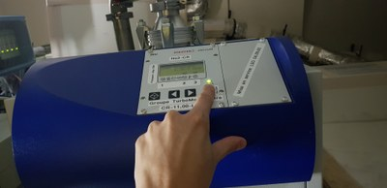
Open straight after the black valve completely by turning it counterclockwise (do not delay this step, the pump is on).
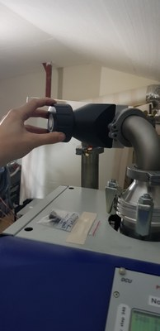
On the controller, use the arrow buttons to display the value 340 on the screen.
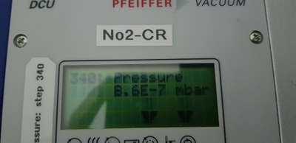
Wait until the pressure of the gauge PKR251 is ≤ than the gauge MPT200.
Now the valve V2 can be opened slowly.
Go back to the pump unit and check that the pressure decrease.
Wait until you reach <8.6x10-5 mbar TBC (~30h)

Cryostat Coralie: Emergency Pumping
if pressure level is > 1mbar (it happens if the cryostat is at room temperature for a long time)
    - Switch on the pump
    - Start the pump unit by pressing the button On/Off
    - Pump the line until the pressure of the PKR251 < MPT200
    - Close the valve V1
    - Open the valve V2 in order to balance the pressures
    - stop the pump unit by pressing the button On/Off
    - wait 20 min (it ensures that the turbomolecular pump stops)
    - start the pump unit by pressing the button On/Off
    - after 1min, open slowly the valve at the pump unit outlet counterclockwise
    - Pump until the pressure is < Wait until you reach <8.6x10-5 mbar TBC (~30h)

Cryostat Coralie: Cooling Procedure

When the pressure is reached, it is time to cool the cryostat.
The cooling must imperatively be done with the pumping in function.
The cooling is started:
1) by typing this command on a terminal on glslogin1
set_lakeshore -C -115.0
this command gives the regulation setpoint to the Lakeshore
2) by opening the valve 1 on the TP60
3) by doing a manual filling of the cryostat according to the procedure displayed against the wall next to the timer (near the TP60)

When the Cryostat is filled, wait until the CCD is at its operating temperature (-115[d])
When the CCD reach the operating temperature it's time to stop the pumping

Cryostat Coralie: Pumping Stop Procedure

Do the following operations in order:
- Close the valve of the cryostat by turning it clockwise and do not force it excessively
- Close the valve of the pump unit in clockwise and do not force it excessively
- Switch off the Pfeiffer Controller
- Wait at least 10 minutes (or days...) and switch off the pump unit with the rear switch

END

