Changement ferrules ligne LN2 Coralie

- In order to prevent unintentional cooling, valve 1 of TP 60 must imperatively be closed as shown on the picture

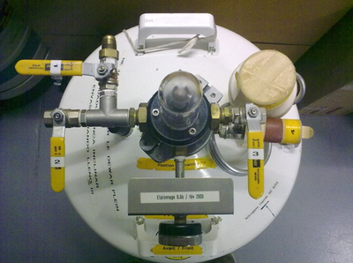

- Take the new brass fittings from the spare parts cabinet in the "Cryogenic maintenance" box
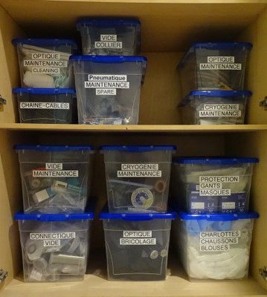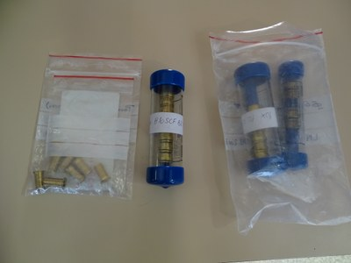

- Remove the tape from the insulation to gain access to the fittings. Remove them.Shorten the insulation by about 20mm and the plastic tube.
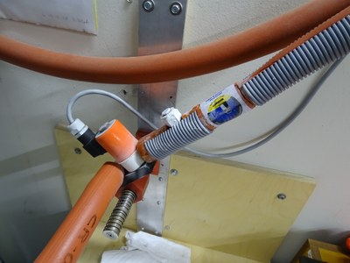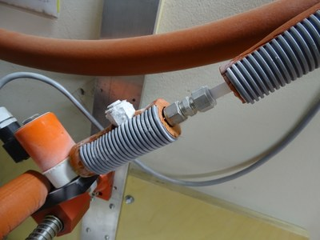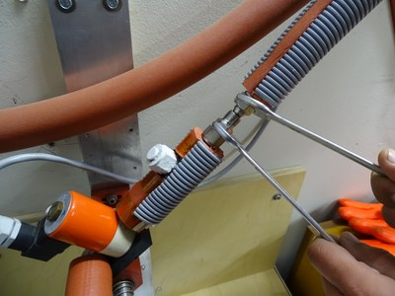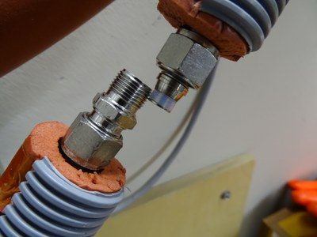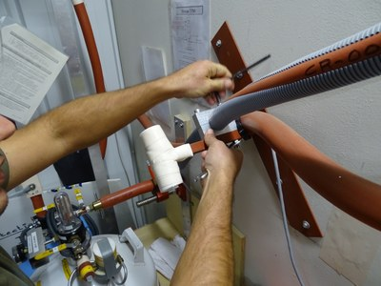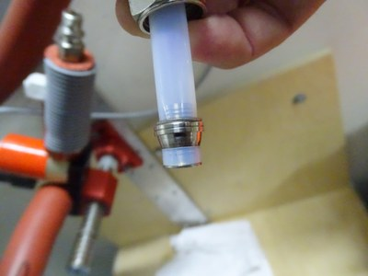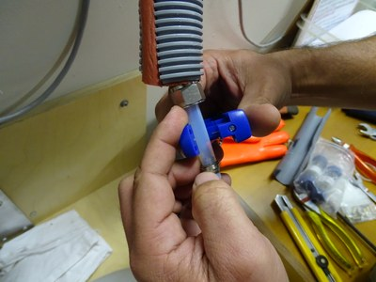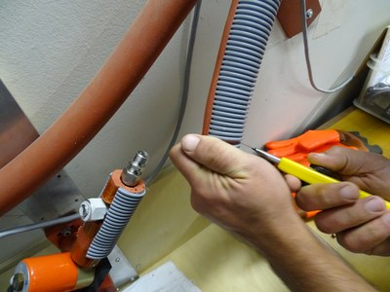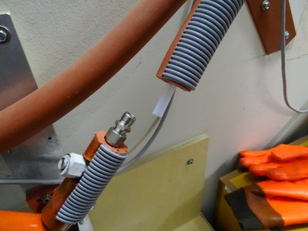

- Put the brass reinforcement insert in the plastic tube, install the nut and the ferules on the tube (pay attention to the direction). Mount the assembly on the fitting by pushing the plastic tube well into it. Tighten the nut firmly so that the ferrule fits into the plastic.

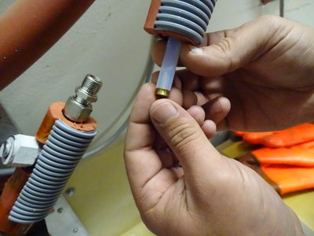
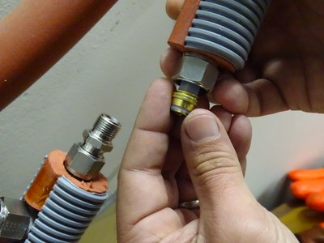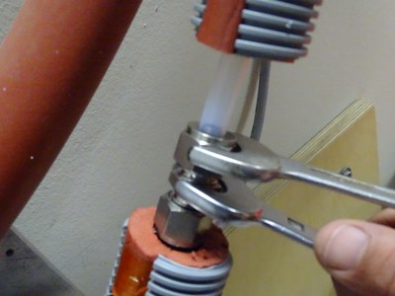

- Go to Coralie's room, BEWARE OF THE FIBERS ON THE FLOOR. Remove the false-roof plate above the instrument.

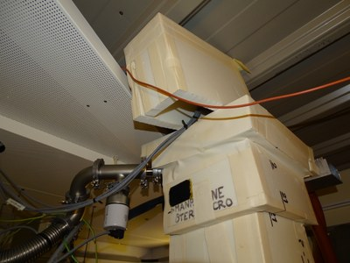

- Remove the black strap and remove the insulation around the nitrogen distribution
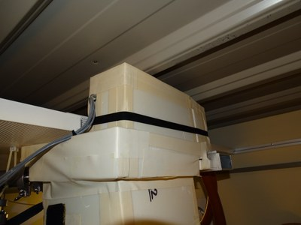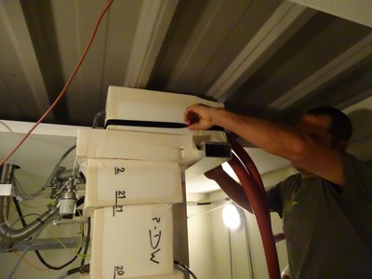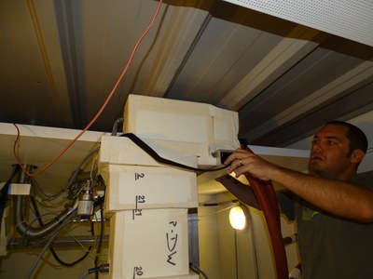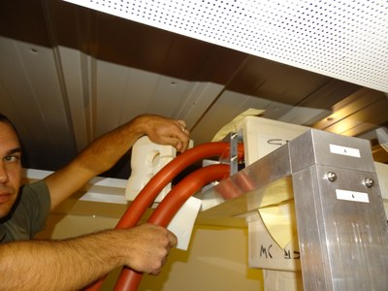
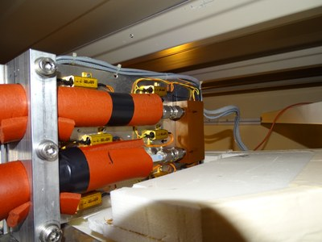

- Replace the ferules in the same way as for the exterior.
- Test the tightness by opening the nitrogen valve. Make sure that there is no leakage at the ferrules
- Replace insulation, roof, etc.

