RANGER instructions

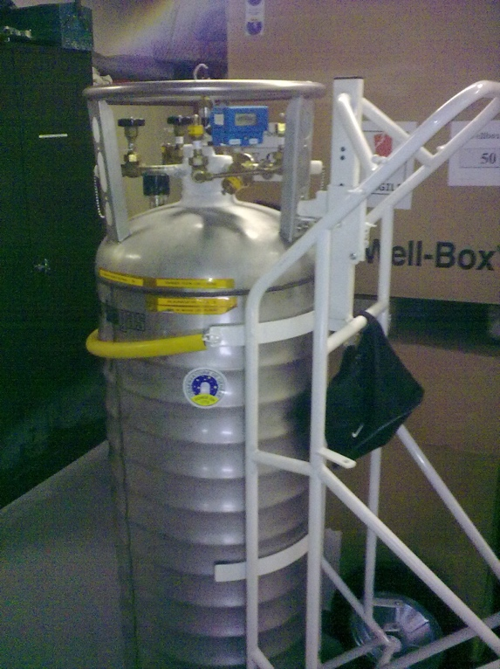

Liquid nitrogen orders

- When the RANGER level reaches 4 bars, it is time to request the refilling of the other dewar. When the RANGER level reaches 2 bars, it is time to exchange the dewar.
- The instructions to order liquid nitrogen « Liquid nitrogen order » are on the board next to the entrance to the control room. You have to order the « gran dewar »

Exchange of the empty RANGER by a full one
- Put on PPE (Gloves/Goggles/Corresponding clothes)
- Close valve W1 (LN2 In/Out)
- Loosen the brass nut
- Put the plastic cap on the W1 outline
- GENTLY toggle the Ranger on an inclined position
- Position the full Ranger in place of the empty one, the small casters must bear against the rear of the aluminum stop profile. Put it GENTLY in a vertical position
- Connect the transfer hose screwing the brass nut
- Open valve W1
- Verify:
  - Pressure 1.7 bars
  - No leak on the transfer

