EULERCAM LIQUID NITROGEN REFILLING

Generally, the refilling of EulerCam is at the beginning and the end of the night.

If is not possible to go to the station, it is imperative to refill it every 20 hours (EulerCam can keep temperature 20 hours only if there are no telescope movement)

How to refill?

- Connect the filling tube to the camera
- Screw the nut by hand (it should be tight, not just loosely in place, otherwise the liquid nitrogen will not fill the camera's tank)
- Press the green button which controls the filling electro valve
- When liquid nitrogen flows through the white end of the camera overflow, turn the switch to 0 position and then 1 position, this will stop the filling

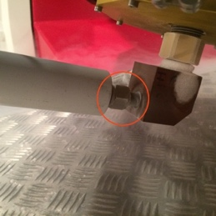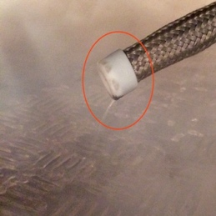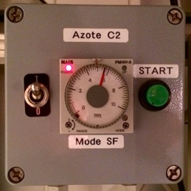

Evening refill

When liquid nitrogen filling is completed, unscrew the nut of the filling tube, store the tube in its housing and close the white security holding the tube in it (without it, the telescope will not start).

Morning refill

When liquid nitrogen filling is completed, leave the filling tube connected to the camera

Comments

In case of high humidity, the nut of the filling tube can remain frozen and stuck to the camera. In this case, you have two possibility, waiting 30 minutes until the nut unfrozen or using the hair dryer behind the lift table at the telescope floor (not too much, to not heat the tank)

