**TP60 instructions**

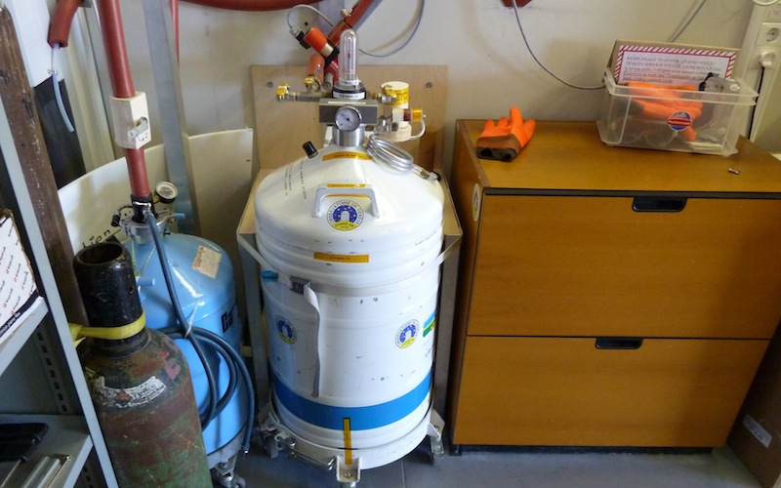

**Liquid nitrogen orders**

* When the TP60 level arrive between the two transparent lines just above the red line, it is time to order the other dewar refilling. **When the TP60 level reaches the red line, it is time to exchange the dewar.**
* The instructions to order liquid nitrogen « Liquid nitrogen order » are on the board next to the entrance to the control room. You have to order the « pequeño dewar »

**Preparation of a full TP60**

When you have received the refilled TP60, proceed as follows:

* Put on PPE (Gloves/Goggles/Corresponding clothes)
* Verify that transfer’s valves are positioned as shown on the next picture

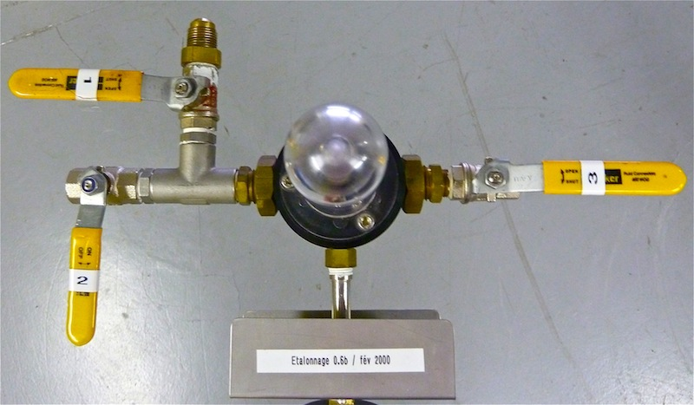

Transfer listo para ser montado en el dewar

* Insert the green seal on the transfer and hold it at the top to be sure it does not come into contact with the liquid nitrogen
* SLOWLY go down the transfer into the dewar
* Position the manometer in front of the yellow sticker « position manomètre »
* Place the collar in the same position as the empty dewar and tighten it
* Closet valve N°3
* Open valve N°4 in order to pressurize the dewar

The dewar must be in this configuration:

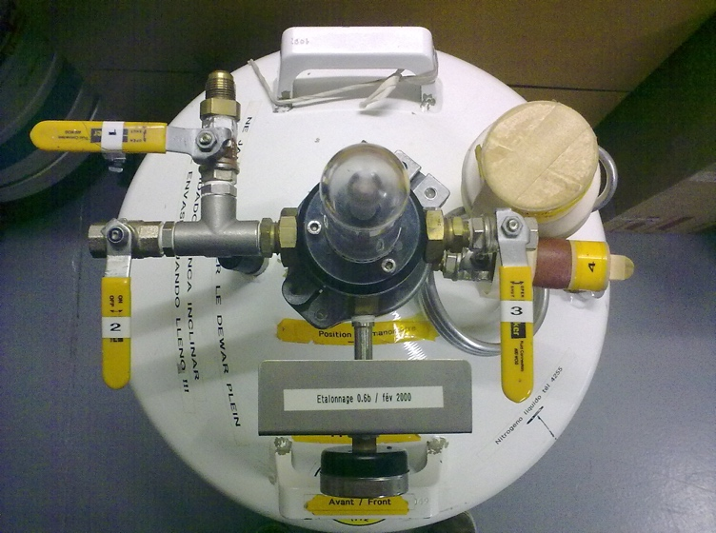

TP60 ready to be exchanged

**Exchange of the empty TP60 by a full one**

* Put on PPE (Gloves/Goggles/Corresponding clothes)
* Close valves N°1 and N°4
* Loosen the brass nut
* Remove the white strap
* Take the empty TP60 out of its housing
* Place the full TP60 so that the N°1 outlet is in front of the transfer hose
* Tighten the white strap
* Screw the brass nut
* Open valves N°1 (and N°4 if it’s not done yet)

The dewar must be in this configuration:

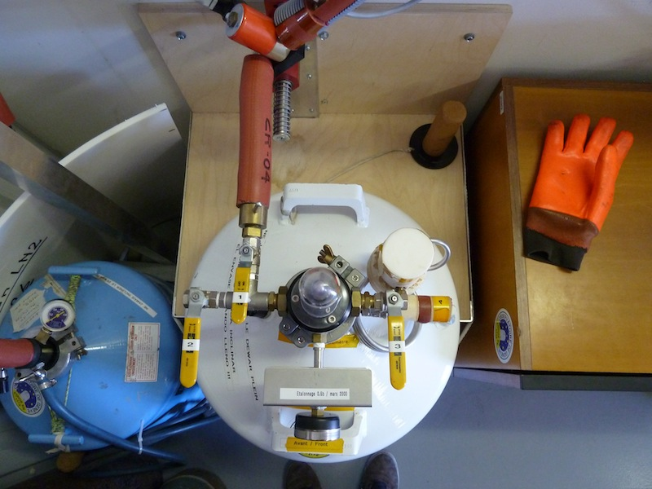

Full dewar ready and in its housing

**Disassembly of the empty TP60**

* Put on PPE (Gloves/Goggles/Corresponding clothes)
* Close the valve N°4 (if it’s not done yet)
* Make sure that there is nothing within 2m of valve N°3 and then open it to release pressure
* Let the pressure drop to 0 bar
* Loosen the collar, remove it and place it on the cardboard plate marked TP60
* GENTLY pull out the dewar’s transfer and place it on the cardboard plate marked TP60
* Remove the green seal and place it on the cardboard plate marked TP60

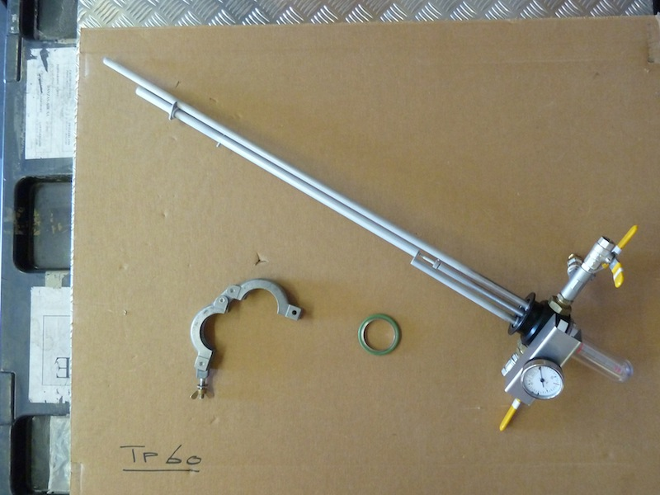

* Put the cap on the dewar

The empty dewar is ready for refilling

(WHEN THE TRANSFER IS NOT MOUNTED ON THE DEWAR, THE VALVE N°4 MUST ALWAYS BE CLOSED)

**« Manual » refill with TP60**

**ONLY IN CASE OF EMERGENCY OR TIMER FAILURE**

If for some reason Coralie gets warmer, it should be manually refilled

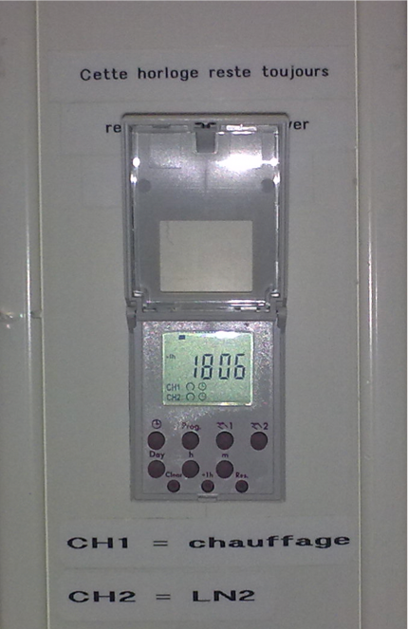

Timer for manually refill

* Follow the procedure displayed against the wall next to the timer

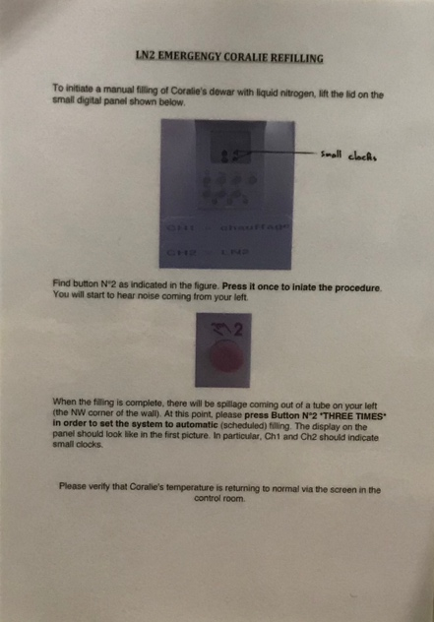

*Procedure for manual refill*